Computer Systems Architecture (CSCI-6461 - 10116)

Homework Exercise #1 – Worth 10%

Cutoff: Sunday October 19th @ 8PM

**Assignment**.

**Problem Statement**: The NZCV bit pattern required for signed conditional codes is sometimes more difficult to understand than unsigned conditional codes. Consider, for example, the NZCV bit pattern for signed *less than or equal to*. This requires NZCV pattern: Z OR (N **⊕** V). Comparing this to unsigned lower or same: Z OR C̄.

You are required to develop a 15-minute educational-focused presentation (slides and video), explaining how the NZCV status shown below (rightmost column) comes about. You will need to discuss each of these four condition codes individually in your presentation:

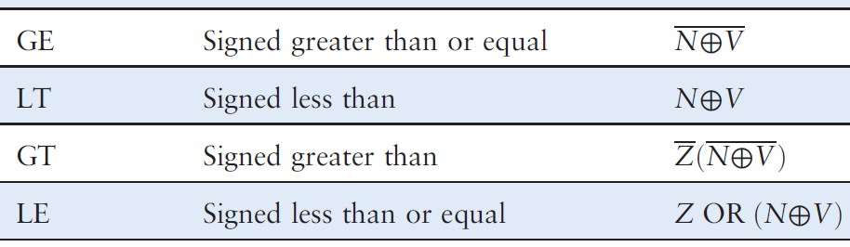

Your explanation may use examples from an 8-bit (rather than a 32-bit) CPU word size if you prefer. Take an educational and learning based approach. You should aim for clarity and accuracy with excellent communication skills.

**Rubric:**

1. 1-3% poor clarity, low educational value, video too short, approximate results
2. 4-5% average clarity, average educational value, video too short, with correct results
3. 6-8% good clarity, good educational value, video 15 mins+, with correct results
4. 9-10% excellent clarity, excellent educational value, video 15 mins+, with correct results

The presentation should be aimed at a knowledgeable undergraduate audience.

**Deliverables**:

Under your csci-6461 github classroom private repo, place the following artefacts in a directory called hw-1:

1. README.md with a url link to a video recording of you presenting your work, minimum 15 minutes duration. (best to use youtube and delist the url)
2. Slides in PDF format

***Note****: Submitting work based wholly or in part on AI or other web resources, will result in a grade of 0*